# OVERVIEW

In this lab you will explore and configure the components that are used to implement Active Directory replication.

# OBJECTIVES

* Be able to monitor replication from the GUI and command line.
* Be able to create and configure an Active Directory site.
* Be able to create and configure an AD subnet object.
* Be able to create and configure Active Directory site link objects.
* Be able to view the properties of AD replication objects.

PREREQUISITES

Lab – Removing a Domain Controller is complete

# SCENARIO

ABS Corporation would like you to configure Active Directory to optimize replication between the three locations and to configure the sites so that clients can take advantage of site aware services.

# TASKS

In this next section, you will view the default replication configuration. Some of the information will be blank as these settings are not configured by default.

## VIEWING THE AD REPLICATION TOPOLOGY

1. Login to the **CIS256-DC1** virtual machine with the **abscorp** administrator account.
2. Open **Active Directory Sites and Services** by typing **dssite.msc** in the **Run** dialog box, **Search**, or **PowerShell**.
3. Document the following information: (**Note**: some parts will be blank)

### SITES

**Note**: You can also use the Get-ADReplicationSite cmdlet.

|  |  |
| --- | --- |
| **Name** | **Associated Subnets** |
|  |  |
|  |  |
|  |  |

### SITE LINKS

**Note**: You can also use the Get-ADReplicationSiteLink -Filter * cmdlet to view some of the information.

The site link objects are in the Sites🡪Inter-Site-Transports🡪IP and SMTP nodes.

|  |  |  |  |
| --- | --- | --- | --- |
| **Name** | **Replication Schedule** | **Replication Interval** | **Cost** |
|  |  |  |  |
|  |  |  |  |
|  |  |  |  |

**Note**: You can also use the Get-ADReplicationSubnet -Filter * cmdlet to view some of the information.

### SUBNETS

|  |  |  |
| --- | --- | --- |
| **Name** | **Site** | **Prefix/Subnet** |
|  |  |  |
|  |  |  |
|  |  |  |

## MONITORING AD REPLICATION

### USING DCDIAG TO TEST\VERIFY REPLICATION

1. Logon to the **CIS256-DC1 (ABSDC1)** virtual machine as the **ABSAdmin**.
2. Open **PowerShell (Admin)**.
3. Type the following command to test if any Domain Controllers are cutoff from their replication partners (**Cutoffservers** test):

dcdiag /test:CutoffServers

1. Use the **dcdiag** command to run the following tests:
   1. Connectivity
   2. Intersite
   3. KccEvent
   4. Replications
   5. Topology

## USING POWERSHELL TO TEST\VERIFY REPLICATION

1. Logon to the **CIS256-DC1 (ABSDC1)** virtual machine as the **ABSAdmin**.
2. Open **PowerShell(Admin)**.
3. Type the following command to provide a summary of replication:

repadmin /replsummary

1. Type the following command in PowerShell to identify replication failures:

Get-ADReplicationFailure -Target absdc1, chdc, ltdc.lametech.com

1. Type the following command to provide the status of replication between its partners:

***repadmin /showrepl***

1. Type the following command in PowerShell to view replication data:

Get-ADReplicationPartnerMetadata -Target absdc1, chdc, ltdc.lametech.com | Select Server, LastReplicationAttempt, LastReplicationSuccess, Partition | ft -Autosize

## CREATING AND CONFIGURING REPLICATION OBJECTS

### CREATING AND CONFIGURING SITE OBJECTS

Rename the **Default-First-Site-Name** site using ***one*** of the following procedures:

#### Using the GUI

1. Logon to the **CIS256-DC1 (ABSDC1)** virtual machine as the **ABSAdmin**.
2. Open **AD Sites and Services**
3. Navigate to the **Sites**→**Default-First-Site-Name** and select **Rename** from the **context menu.**
4. Change the site **name** to **Greenville.**

#### Using PowerShell

1. Open a PowerShell Session and type the following:

Get-ADReplicationSite -Identity Default-First-Site-Name | Rename-ADObject –NewName Greenville

#### Using the GUI

Create a site for the **Pickens** location using the following procedure:

1. Logon to the **CIS256-DC1 (ABSDC1)** virtual machine as the **ABSAdmin**.
2. Open **AD Sites and Services**
3. Navigate to the **Sites** node
4. Select **New Site…** from the **Sites** node **context menu**.
5. In the **New Object - Site** dialog box **type Pickens** in the **Name**: textbox and **select** the **DEFAULTIPSITELINK** site link object.
6. Click the **OK** button.

#### Using PowerShell

1. Open a PowerShell Session and type the following:

New-ADReplicationSite -Name Charlotte

### CREATING AND CONFIGURING A SITE LINK OBJECT USING THE GUI

Create a Site-Link object to link the Greenville site to the Charlotte site.

1. Open **AD Sites and Services**
2. Navigate to the **Sites**→**Inter-Site Transports** node
3. Select **New Site Link…** from the **IP** node **context menu.**
   1. In the **New Object - Site Link** dialog box **type Greenville-Charlotte** in the **Name**: textbox and **verify** that the **Greenville** and **Charlotte** sites are **listed** in the **Sites in this site link:** box.
4. Click the **OK** button.

Configure the replication schedule between the **Greenville** site and the **Charlotte** site using the following procedure:

1. Open **AD Sites and Services**
2. Navigate to the **Sites**→**Inter-Site Transports**→**IP** node.
3. Open the **properties** for the **Greenville-Charlotte** link
4. Type **Site Link between Greenville and Charlotte** in the **Description** textbox.
5. 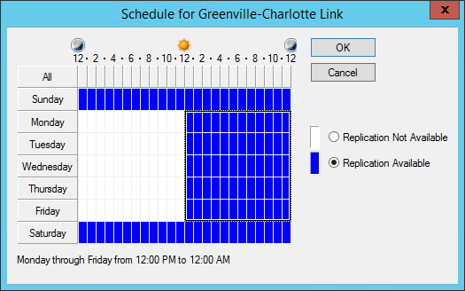Type **15** in the **Replicate every….minutes** box.
6. **Click** the **Change Schedule** button and **set** the **replication** schedule to:
   1. **All Day Saturday and Sunday**
   2. **Monday through Friday 12PM to 12AM**
7. Your schedule should look like the one on the right.
8. Click the **OK** to exit the **Site-Link** dialog box.
9. What effect will this have on replication between the **Greenville** and **Charlotte** sites?

### CREATING AND CONFIGURING A SITE LINK OBJECT USING POWERSHELL

Create a Site Link object for replication between Greenville and Pickens as follows:

1. Open a **PowerShell (Admin)**.
2. Type the following command to create a **Site Link** object:

New-ADReplicationSiteLink -Name Greenville-Pickens -Description "Site link between Greenville and Pickens" -SitesIncluded Greenville,Pickens -InterSiteTransportProtocol IP -ReplicationFrequencyInMinutes 15 -Cost 100

1. Type the following to verify the settings:

Get-ADReplicationSiteLink -Identity Greenville-Pickens

1. 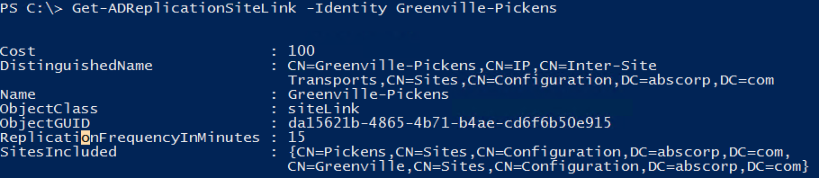Your output should look like the screen below:
2. Create a **Site Link** object, using one of the methods above, with the following settings:
   1. Name: **Charlotte-Pickens**
   2. Description: **"Site link between Charlotte and Pickens"**
   3. Sites in Link: **Charlotte and Pickens**
   4. Replicate Every: **15 minutes**
   5. Cost: **100**
   6. Replication Schedule: **All day every day**

## MOVING A SERVER TO A DIFFERENT SITE USING THE GUI

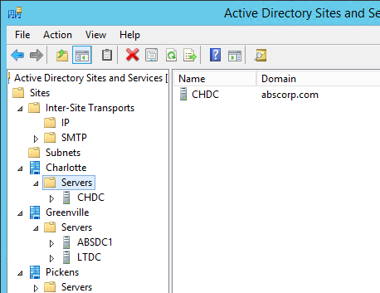Move the Charlotte DC (CHDC) to the Charlotte site using the following procedure.

1. Open **AD Sites and Services**
2. Navigate to the **SitesàGreenvilleàServers** node.
3. Select **Move**... from the **CHDC** node context menu.
4. In the **Move Server** dialog box choose the **Charlotte** site and then click the **OK** button.

## MOVING A SERVER TO A DIFFERENT SITE USING THE POWERSHELL

Move the Pickens DC (LTDC) to the Pickens site using the following procedure:

1. Open a **PowerShell (Admin).**
2. Type the following command to move the LTDC domain controller to the Pickens site:

Move-ADDirectoryServer -Identity LTDC -Site Pickens

1. Verify the domain controller was moved using the following command:

Get-ADDomainController -DomainName lametech.com -Discover

1. 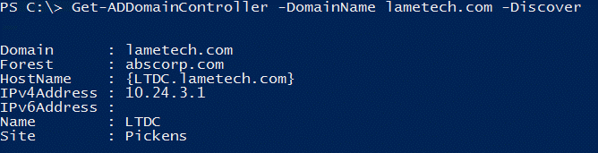You should see the output below:

## Creating AD Subnet Objects

Subnet objects are used by Active Directory to allow computers and users to determine their site membership. When a machine boots, it uses its IP address to determine its subnet. It then queries Active Directory to determine the site associated with its subnet. It uses this information to locate a domain controller or other service within the site to use.

### CREATING A SUBNET OBJECT USING THE GUI

Create a subnet object for the Greenville location as follows:

1. 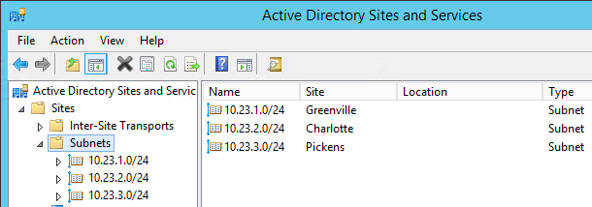Open **AD Sites and Services**
2. Navigate to the **Sites** node
3. Select **New Subnet..** from the **subnets** node **context menu**
4. In the **New-Object - Subnet** dialog box **type** **10.1.1.0/24** in the **Prefix**: textbox and select the **Greenville** site and then click the **OK** button.

### Creating a Subnet object Using PowerShell

Create a subnet object for the Charlotte location using the following procedure:

1. Open a **PowerShell (Admin)**.
2. Type the following command to create a subnet object for Charlotte:

New-ADReplicationSubnet -Name 10.1.2.0/24 -Site Charlotte

1. Create a **subnet** object for **Pickens** that uses the **10.1.3.0/24** network address, using one of the procedures shown previously.

## Submission requirements

1. **Download** the **grading** **script** from the assignment page to the **C:\Scripts** folder.
2. Check your lab by running the following command:

Invoke-Pester -Path C:\Scripts\GP10-Configuring_Active_ Directory_Replication.test.ps1

**Note**: You will see a security warning when running the script. Enter **R** to run the script.

If you want to see more detail, add **-Output Detailed** to the command. This may assist you with troubleshooting

Invoke-Pester -Path C:\Scripts\GP10-Configuring_Active_ Directory_Replication.test.ps1 -Output Detailed

1. You should not see any red in the output. Red in the PowerShell way of telling you that an error condition exists. Most of the time, the output will tell you what is wrong. If it is not obvious, contact your teacher and ask for assistance. You will be learning PowerShell during this term. **Correct** any **errors** you may have and run the script until all the output has no red. You should see the output like the images below.

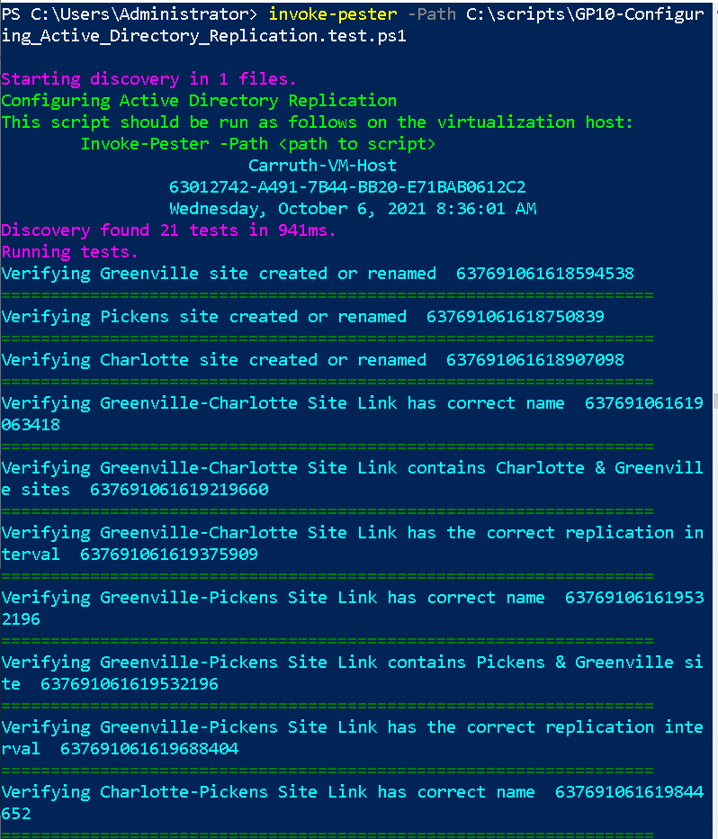

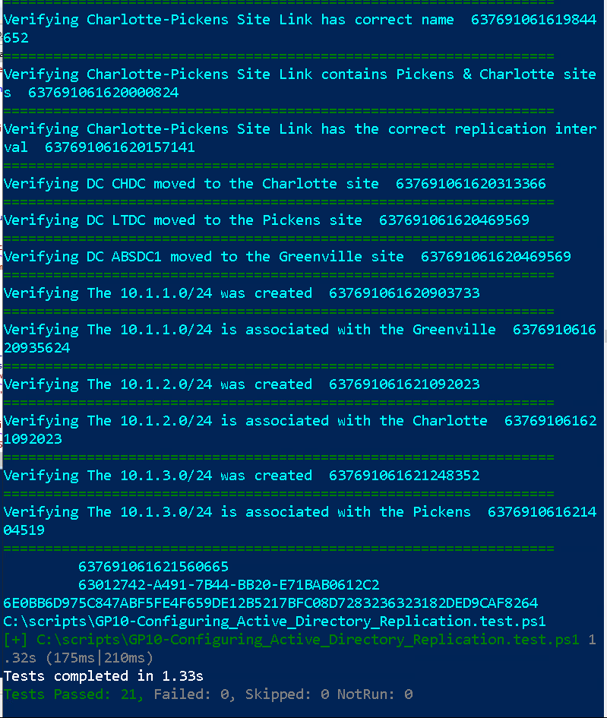

1. Capture a snippet that shows the PowerShell Command and all its output. If you must use more than one snippet to capture the output, you must have at least **one line of overlap** in the snippets. The text in the snippets **must be legible** when pasted into the Word document. Paste the snippet(s) into a **new** **Word** **document.**
2. **Upload** the **document** in the submission area for the assignment.